

Date: July 23rd, 2019

Application Note Number 19-001

Paint on various substrates:

Challenge: non-destructive thickness measurements of paint on non-ferrous materials.

History: Most conventional coating thickness gages using eddy current or magnetic induction or other magnetic techniques can easily and accurately measure the thickness of paint on metals such as that on an automotive hood. They can not measure paint on non-metal materials such as plastic bumpers, composites, wood or concrete.

Solution: ECHO 7 or 8 series with or without the live waveform. With the latest version of Danatronics ECHO series in precision mode, the operator can easily recall from the standard probe library the default stored setup for Paint on plastic or paint on metal (see image 1). This measurement is done with a conventional 5 Mhz., .25” delay line. The thickness range of the paint is from .001” or 25.4 Microns to .100” or 254 microns. It is very important that the probe and part being tested are done in a stable temperature environment. It is important to know the substrate material so that the proper setups of the gage is choosen for the proper echo detection as a “phase reversal” will occur of the reflected signal with different substrates. In a paint on plastic scenario, the echo detection should be positive going as shown in image 2. While paint over metals should be set to detect a negative going signal.

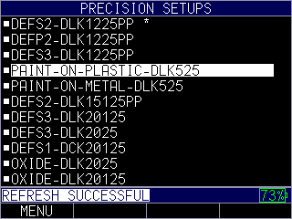

Image 1: stored setup menu

Advantages:

Cannot make measurement with conventional coating gages

Can measure paint on many substrates like plastic, steel, aluminum, composites, wood and concrete

Easy to use

Accurate

Disadvantages:

Temperature must be stable at the time of reading

Occasional probe re-zero is needed

Must properly know substrate material

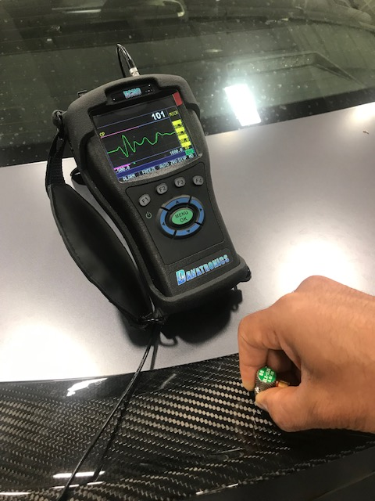

Image 2, image show 101 microns or .0039” of paint over composite



Paint on metal hoods



Paint on bumpers