Date: July 23rd, 2019

Application Note Number 19-003

Auto Calibration

Challenge: remembering the various key presses on an ultrasonic thickness gage when performing a 2- point calibration.
History: To perform a 2-point calibration on an ultrasonic thickness gage requires a specific set of key presses. These key presses can vary from not only vendor to vendor but also with various models within a single supplier.

Solution: Danatronics has introduced, as of the summer of 2019, a patent pending and unique auto calibration in all of our 30 plus models except our very basic EHC-03 which has both a 2-point calibration as well as a fixed velocity chart of common materials such as steel, aluminum, stainless and plastics. This feature is also available on original gages such as EHC-09 and UPG-07 series making it ideal for lower level technicians.

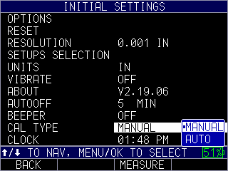
Switch from manual cal to auto cal

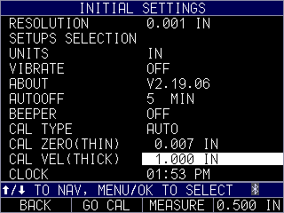
Enter thin and thick values of the full test range. Note quick keys above F4 for common .500” on thick
And F2 Go Cal

Advantages:

Easy to use and understand
Great for low level technicians
Now available in our lower end gages
No key presses required

Dis-advantages:
“garbage in and garbage out” so if the wrong values are entered that the gage and probe combination can handle, it will not work!

