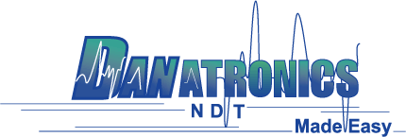

Date: July 23rd, 2019

Application Note Number 19-004

Echo to Echo and Coating thickness measurements

Challenge: Ability to either ignore the paint or coating and measure just the substrate and also measure both coating and substrate at their independent velocities.

History: Many applications in the Corrosion thickness applications have painted surfaces on vessels, ship hulls, pipes, bridges and tanks. In the past, the customer would spend the time and money to remove the coating knowing the thickness of the coating has nothing to do with the integrity of the substrate but ever more, the coating thickness introduces an error. In addition, the part then needs to be re-painted. When using a conventional gage without echo to echo (ignoring the coating), the error is simple to calculate. The thickness on conventional gages is based on one sound velocity, that typically of steel. Since coatings have roughly 2.5 times slower sound speeds than steel, a .010” coating would automatically introduce an error of .025’ (.010” x 2.5). ECHO To ECHO measures the sound bouncing in the steel only thus ignoring the coating. We now also have the ability to measure the coating and the substrate at their independent velocities with the ECHO 9W or ECHO 9DLW. The use of the live waveform is recommended to look for mode converted echoes (Longitudinal waves becoming shear waves) as well as the ability to adjust gain and blanks…both main bang blank and blank after first detected echo.
Solution:
Use the echo to echo technique to ignore coatings. Models include:

EHC-09, EHC-09DL,EHC-09W, EHC-09DLW, All ECHO series

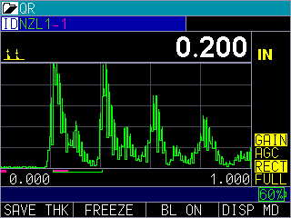
ECHO To ECHO on, see top left yellow peak symbol, also main bang and blank after
First detected are on, see fushia colored lines on the bottom of the screen.

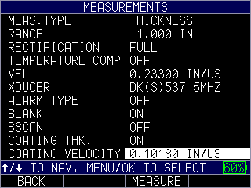
Turning on coating in ECHO unit, generic velocity is set

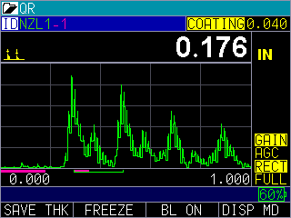
After a two-point substrate thickness and coating velocity cal, we display both substrate and coating thickness.
Advantages:

Ignores coatings which introduce an error
Not affected by couplant or pressure
Saves time and money by not having to scrap and re-paint the parts
Easy to use
Most gages are upgradeable to add this feature
ECHO series can display both coating and substrate at their independent velocities, save to memory and excel as well. This is also performed with a generic an in-expensive dual which our competitors use an expensive and patented technique.

Disadvantages:

Substrate must be at least .080” or 2mm
Substrate must be bonded
May require a more heavily damped probe such as DK-537EE or DK-718EE
A little more costly for the feature
Be aware of mode converted echoes

